Programme 5 - Practice task

The following file: dwellings.csv contains comma delimited data from the last 3 census to do with what type of dwelling residents reside in. The CSV file contains the following columns

0. Region
- 2001 Seperate House
- 2001 Apartment
- 2001 Other
- 2001 Undefined
- 2001 Total
- 2006 Seperate House
- 2006 Apartment
- 2006 Other
- 2006 Undefined
- 2006 Total
- 2013 Seperate House
- 2013 Apartment
- 2013 Other
- 2013 Undefined
- 2013 Total
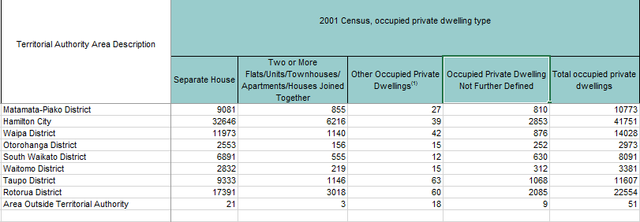

The data looks like this:
Thames-Coromandel District,8208,1059,141,1446,10860,9465,1062,288,567,11379,9930,1176,243,651,12000
Hauraki District,5634,408,45,498,6585,6222,423,114,273,7032,6564,390,108,363,7422
Waikato District,15060,1005,84,1368,17517,17211,900,213,1461,19788,19410,1002,231,1491,22140

Task 1:
- Open File
- Read line of string into a variable eg: line = reader.ReadLine();
- Split data into an Array (16 fields) eg: resultData = line.Split(',');
- Save each field of required data into separate variables
eg: total2001 = resultData[6];
- Display on the screen the region followed by the the 3 totals for each year
- Ensure you Pad your results to line them up eg:total2001.ToString().PadRight(6)

Task 2:
- Create a Method to calculate the average of 3 numbers, it should accept 3 integers and return the average integer (whole number): Public int CalcAverage(int num1, int num2, int num3)
- Call this method and display the average alongside the 3 totals

Task 3:
- Create a file called DwellingOutput.txt hint: use writer = File.CreateText(filename)
- Write a header line into the file
- Write the data (padded) into the file
- Close the file

Extension Challenge
- Store the data into a list or dictionary

